Name: ____________________ | Class: ____________________ | Date: ____________________
🐾 Week 7 Grade 1 Science Homework 🐾
Unit 4 • Comparing Animals

- Circle the correct answer. Look carefully at each animal or body covering.

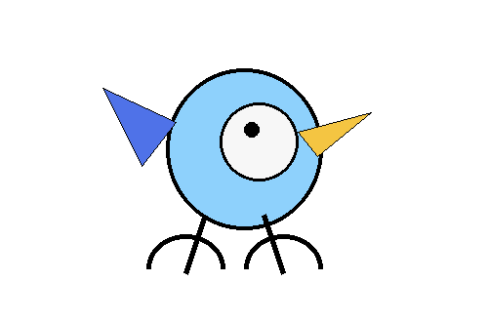 | 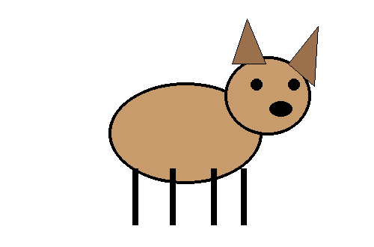 | 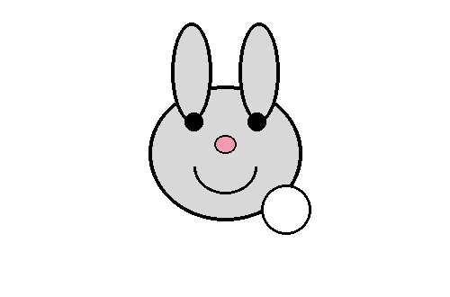 | 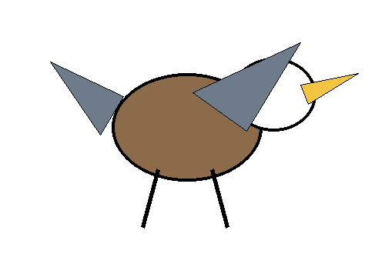
☐ bird ☐ mammal | ☐ bird ☐ mammal | ☐ feathers ☐ fur | ☐ feathers ☐ fur

- Match each animal to the clue. Write the letter of the clue next to each animal.
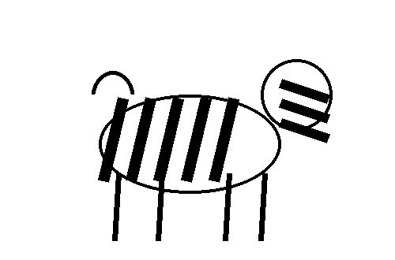  Zebra ______ | 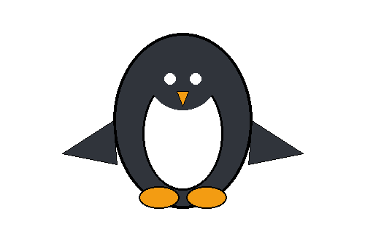  Penguin ______ | 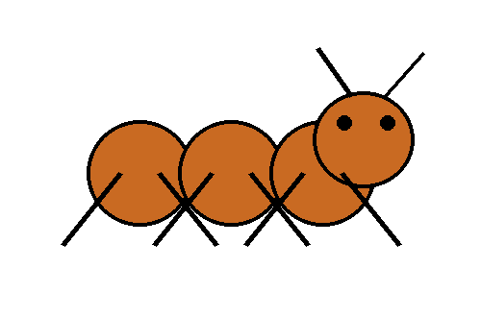  Ant ______
A. has six legs | B. has black and white fur | C. has black and white feathers

Think like a scientist! 🔎
A bird has ____________________.
A mammal has ____________________.
Which animal above has six legs? ____________________
Which two animals above have feathers? ____________________ and ____________________.

4. Animal sorting challenge Put each animal in the correct group.
🐦 BIRDS  ________________________________  ________________________________  ________________________________  ________________________________ | 🐶 MAMMALS  ________________________________  ________________________________  ________________________________  ________________________________

5. Draw and label ✏️ Draw one bird and one mammal. Show what covers their bodies.
My bird | My mammal

